Hand Hygiene for Dental Assistant’s
STEP | ACTION |  | MOMENT | RATIONALE
1 | 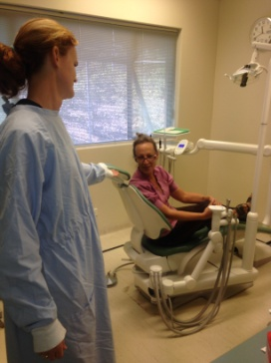   | Ask patient to have a seat | -- | You have not touched the patient yet
2 | 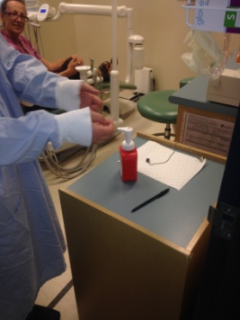 | Perform hand hygiene before touching the patient | 1 | By performing hand hygiene before touch a patient, you reduce the risk of harmful pathogens being transferred to the patient
3 | 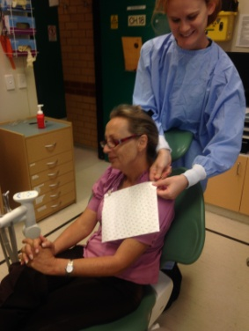 | Place bib on patient --- = | -- | You are now safe to perform non-invasive procedure as required
4 | 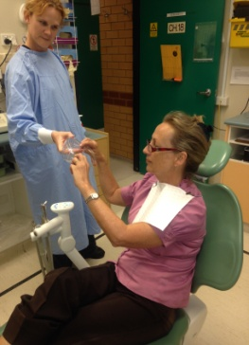 | Hand glasses to patient | -- | You can perform all non- invasive procedures that require touching the patient, as long as you do not leave the patient zone or come into contact with blood or body fluids
5 |  | Perform hand hygiene after touching the patient | 4 | Hand hygiene is performed at this point to protect you from harmful pathogens that may have been transferred to your hands by touching the patient
6 | 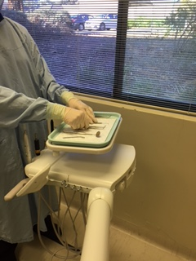 | Put on gloves to set up examination instruments | 2  Bonus  Moment | Setting up is considered a procedure, so you need to perform hand hygiene immediately before setting up to avoid contamination of the packaging and surrounding surfaces, which could transfer to the instruments when removing them from the pack  You do not need to perform hand hygiene again if you did not touch anything after Step 5  For auditors this is considered a ‘bonus moment’  NOTE*: If you need to move out of the patient/contaminated zone to collect additional equipment you will need to perform hand hygiene again before donning gloves IMMEDIATELY prior to setting up.
7 | 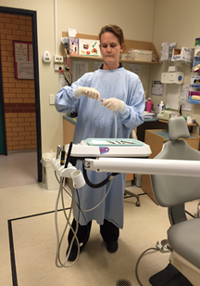 | Remove gloves and perform hand hygiene immediately after setting up  instruments If you are assisting with a procedure, perform hand hygiene, put on gloves and prepare for the procedure. | 2 | This is required because the outside of the packaging is not sterile and has been handled by several people  Hand hygiene is also required because you are leaving the patient zone and will touch the client’s medical record, which we try to keep as clean as possible
8 | 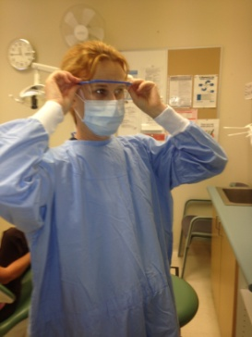 | Put on mask and then  eye protection | -- | Your hands are clean, so you can safely start putting on your PPE
9 | 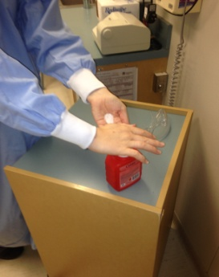 | If at any time during the procedure you need to move OUT of the contaminated zone you MUST remove gloves and perform hand hygiene immediately. | 3 | Hand hygiene is required because you are leaving the patient/contaminated zone and will touch the client’s medical record, which we try to keep as clean as possible.
10 | 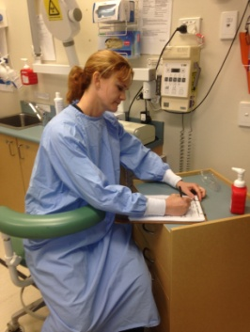   | Complete the clinical assessment | -- | You are now out of the patient/contaminated zone and in the clean zone
11 | 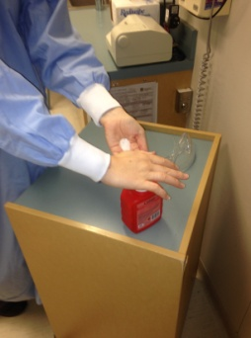 | Perform hand hygiene before putting gloves immediately prior to (returning to assist with) the procedure | 2 | You perform hand hygiene immediately before a procedure to reduce the risk of transferring harmful pathogens that have the opportunity to bypass the body’s natural defences during a dental procedure
12 | 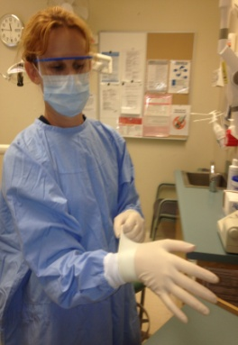 | Put on gloves | -- | Gloves can protect both patients and HCWs from exposure to infectious agents that may be carried on hands  Gloves do not provide complete protection against hand contamination. Pathogens may gain access to the HCWs hands via small defects in gloves or by contamination of the hands during glove removal
13 | 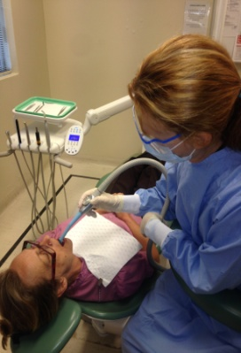 | Start the procedure | --
14 | 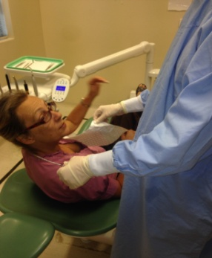 | Remove bib from patient at completion of procedure | -- | As the bib is likely contaminated with blood and/or body fluids from, it should be removed before removing the dirty tray of instruments
15 | 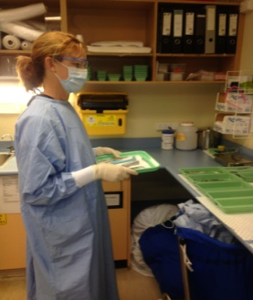 | Take dirty tray to the-sterilising room | -- | The tray must be removed from the surgery immediately after removing the bib to prevent any risk of blood or body fluid exposure
16 | 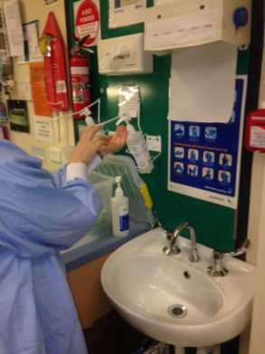 | Remove gloves and perform hand hygiene immediately after blood and body fluids risk from instruments and gloves | 3 | Hand hygiene is performed to protect the dental assistant from exposure to blood borne viruses in blood and body fluids as well as other infectious pathogens
17 | 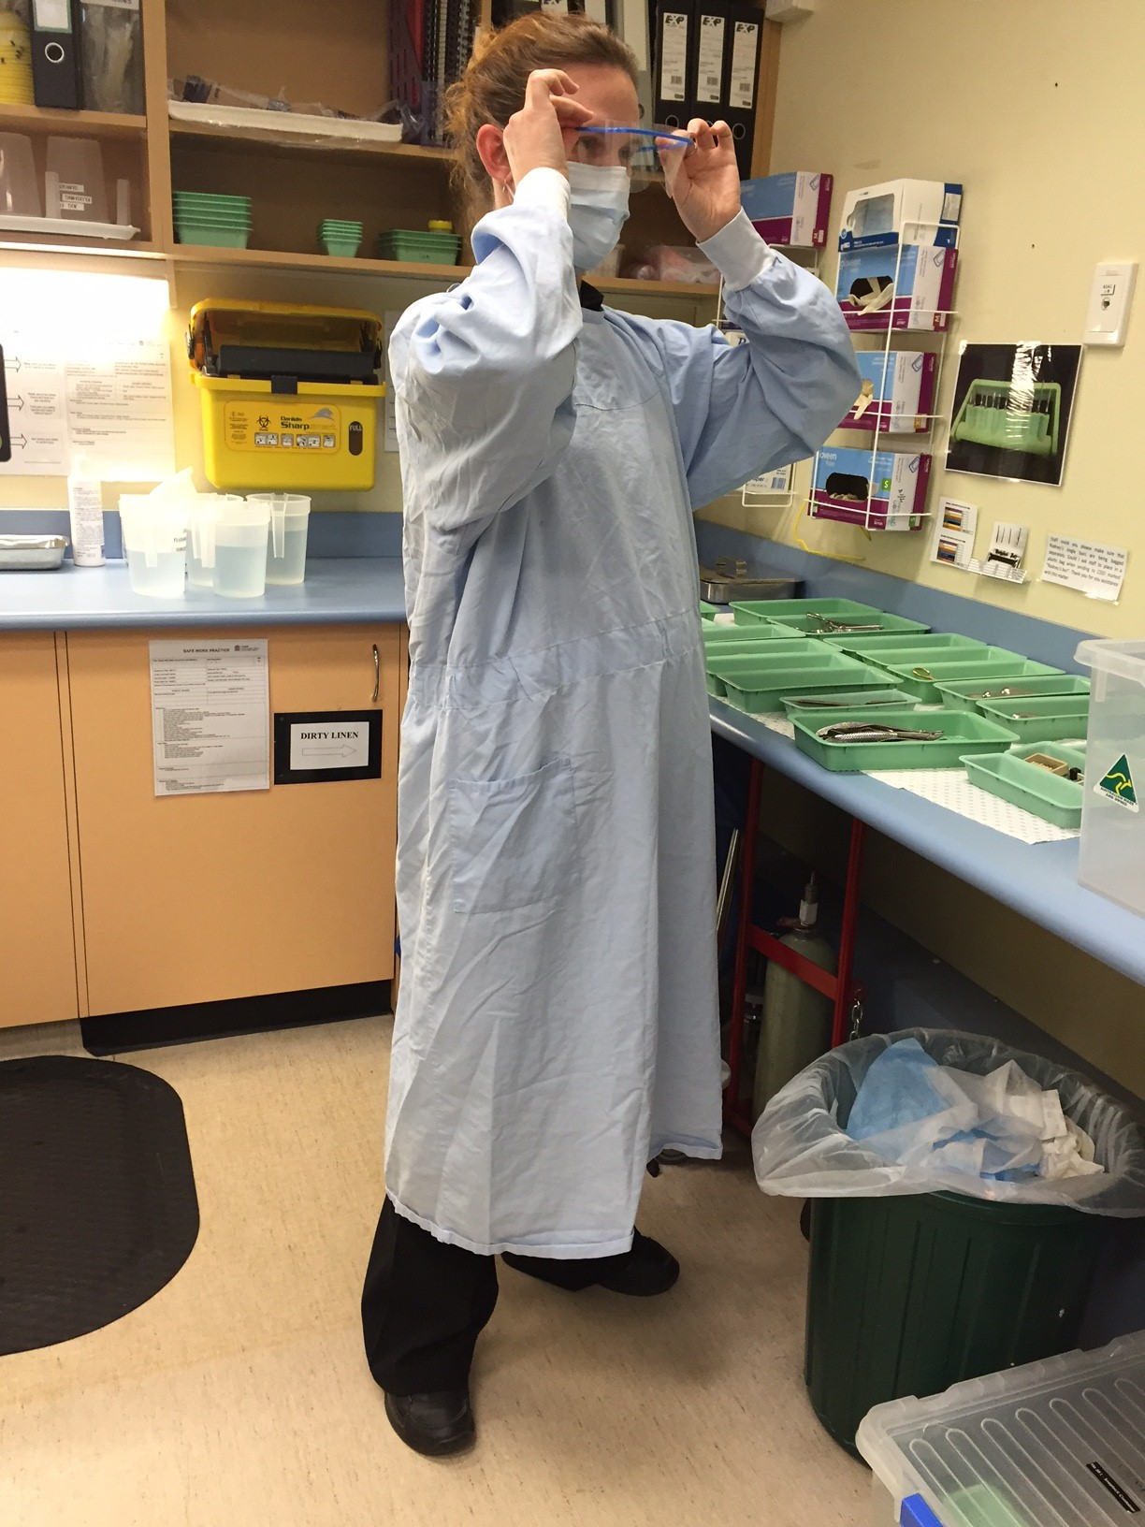 | Remove eye protection then mask | -- | Your hands are clean, so you can safely remove your PPE
18 | 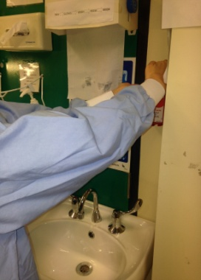 | Perform hand hygiene immediately after blood and body fluids risk from mask and eye protection | 3 | Hand hygiene IS performed after removal of mask and face protection to protect you from the transfer of harmful pathogens that may have contaminated this equipment during the procedure and then transfer onto your hand during removal
19 | 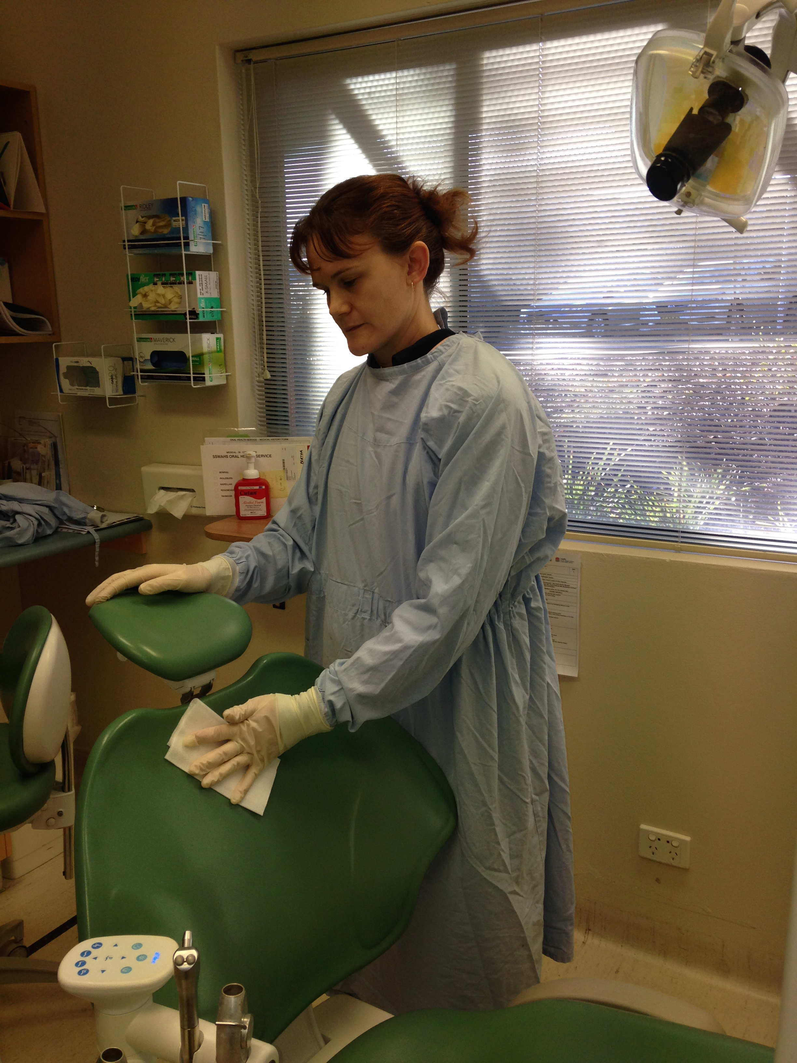 | Clean patient zone wearing gloves | -- | Wearing gloves for cleaning procedures reduces the amount of contamination on your hands and protects your hands from the chemicals in cleaning agents
20 | 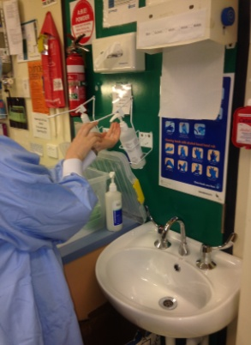 | Remove gloves and perform  hand hygiene after touching the patient zone | 5 | Perform hand hygiene after cleaning to protect yourself from harmful pathogens that may contaminate your hand via imperfections in the gloves or during glove removal
--------------- ---------------------------------------------- ---

